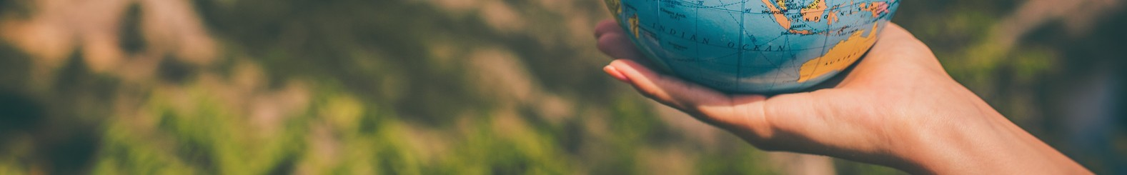

Year 2

Long Term Planning 2025 -2026

|  |  |  |  |  |  |  |  |
| --- | --- | --- | --- | --- | --- | --- | --- |
|  | **Year 2 Planning Overview** | | | | | | |
|  | **Autumn** | | **Spring** | | | **Summer** | |
| **Key Texts suggestions** | * World in Danger by Frankie Morland * Mr Wolf’s Pancakes (tales with a twist similar to Little red Hen) * Also tales with a twist = Pigs Might Fly by Jonathan Emmett, * Into the Forest/Tunnel by Anthony Browne * Biscuit Bear * Mr Wolves’ Pancakes * Little Red Hen | | * Grandad’s island (topic book) * George’s marvellous medicine * The Twits * Dear Greenpeace (letter writing: revisit y1 letters) * Meerkat Mail (letter/ postcard writing) * Little Red Riding Hood was Rotten * The Big Bad Pig * The Same but different * The Tiger Skin Rug * The Big Book of Blue | | | * The diary of a killer cat. * The Hodgeheg * Fantastic Mr Fox * Dear Greenpeace * Handa’s Surprise * The Green, Green Forest * The Boy Who Grew a Forest * Buddy’s Rainforest Rescue * Rainforest Explorers * The Great Yapok Tree | |
| **English/Phonics** | The Write Stuff Units | | The Write Stuff Units | | | The Write Stuff Units | |
| **Purposes for writing** |  | | | | | | |
| **Mathematics**   | Place Value  Addition and Subtraction | Addition and Subtraction  Multiplication and Division | Fractions  Money | | Shape  Statistics | Measurement  Time | Position and Direction |
| **Science** | Uses of everyday materials | Animals including humans | | Living Things and their habitats | | Plants | |
| **Computing** | Using Networks and systems | Digital Photography | Creating Media | | Data and Information | Programming A | Programming B |

|  |  |  |  |  |  |  |  |  |
| --- | --- | --- | --- | --- | --- | --- | --- | --- |
| **History** | The Gunpowder Plot | | Richard III & King Charles II | | | Ruby Bridges goes to school | | |
| **Geography** | Continents and Oceans | | What is it like in New Delhi | | | Air Pollution | | |
| **Art and Design** | Cityscapes |  | | Colour, Pattern and shape |  | | Urban and rural birds eye view |  |
| **D&T** |  | Structures – baby bear’s chair | |  | Mechanisms – Fairground wheel | |  | Mechanisms – making a moving monster |
| **RE** | 1.6 Who is a Muslim and how do they live? Part 1 | 1.3 Incarnation – What does Christmas mean to Christians?*?* | | 1.6 Who is a Muslim and how do they live? Part 2 | 1.5 Salvation – Why does Easter matter to Christians? | | 1.4 Gospel – What is the good news that Jesus brings? | 1.8 What makes some places sacred to believers? |
| **PSHE** | Rights, Rules and Responsibilities  RR12 | My Emotions  ME12  Anti-bullying AB12 | | Working Together  WT12  Financial Capability FC12 | Relationships & Sex Education  RS2 | | Managing Safety & Risk  MSR12 | Digital Lifestyles  Managing Change  MC12 |
| **PE** | Fundamental Movement skills | Dance | | Gymnastics | Tri-Golf | | Striking and Field Games | Target Games |
| **Music** | Voice Unit | Pitch Unit | | Rhythm Unit | Pulse Unit | | Learning Recorders | |