 | Year 3 Planning Overview
 | Autumn |  | Spring |  |  |  | Summer
Key Texts | - Stone Age Boy – Satoshi Kitamura  - How to Wash a Woolly Mammoth – Michelle Robinson  - UG: Boy Genius of the Stone Age and his search for soft trousers – Raymond Briggs  - The Stone Age: Hunters, Gatherers and Woolly Mammoths – Marcia Williams  The Wild Robot – Peter Brown |  | - The Firework-Maker’s Daughter – Philip Pullman  - Escape from Pompeii – Christina Balit  - The Street Beneath My Feet – Charlotte Gullian  Stone Girl, Bone Girl: The Story if Mary Anning of Lyme Regis – Laurence Anholt |  |  |  | - Who Let the Gods Out? – Maz Evans  - Leo and the Gorgon’s Curse – Joe Todd Stanton  - So you think you’ve got it bad? A kid’s life in ancient Greece – Chae Strathie and Marisa Morea  Texts related to pupil interests
English | The Write Stuff |  | The Write Stuff Units |  |  |  | The Write Stuff Units
Writing purposes | 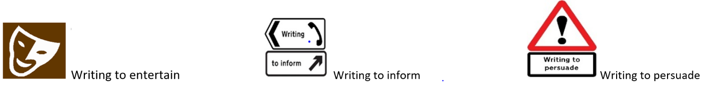
Mathematics   | Place Value  Addition and Subtraction | Addition and Subtraction  Multiplication and Division A  Statistics | Multiplication and Division B  Length and Perimeter |  | Fractions  Mass and Capacity |  | Fractions  Money  Time |  | Time  Shape
Science | Rocks | Light |  | Animals including humans |  | Forces and Magnets |  | Plants

Computing | Computing systems and networks -Connecting Computers | Creating Media - Animation | Programming A – Sequencing Sounds | Data and Information – Branching Databases | Creating Media – Desktop Publishing | Programming B – Events and Actions
History | Stone Ange to Iron Age |  | Ancient Greece |  | The Digital Revolution
Geography | Volcanoes and Earthquakes |  | The Island of Crete |  | Recycling
Art and Design | In my element |  | Creating with metal |  | Improving texture
D&T |  | Food – eating seasonally |  | Digital world – electronic charm |  | Structures – constructing a castle
RE | L2.1 Creation  What do Christians learn from the creation story? | L2.2 People of God  What is it like for someone to follow God? | L2.9 How do festivals and worship show what matters to Muslims? | L2.10 How do festivals and family life show what matters to Jews? | L2.4 Gospel  What kind of world did Jesus want? | L2.12 How do people try to make the world a better place?
PSHE | Beginning and Belonging  BB34 | Family and Friends  FF34  Anti-bullying AB34 | Diversity and Communities  DC34 | Relationships & Sex Education RS3  Drug Education DE34 | Personal Safety  PS34 | Healthy Lifestyles  HL34
PE | Dance | Gymnastics | Hockey | Dodgeball | Basketball | OAA

Music | Rhythm Unit | Pulse Unit |  | Music Technology Unit |  |  | Voice Unit | Pitch Unit
MFL | Me and others |  | What I and others have |  | What I and others do | Numbers |  | Poem

